**11.** **Write a C program to implement Stack operations such as PUSH,**

**POP and PEEK**

**PROGRAM:**

#include <stdio.h>

#include <stdlib.h>

#define MAX_SIZE 100

int stack[MAX_SIZE];

int top = -1;

void push(int value) {

if (top == MAX_SIZE - 1) {

printf("Stack Overflow\n");

return;

}

stack[++top] = value;

printf("%d pushed to stack\n", value);

}

void pop() {

if (top == -1) {

printf("Stack Underflow\n");

return;

}

printf("%d popped from stack\n", stack[top--]);

}

int peek() {

if (top == -1) {

printf("Stack is empty\n");

return -1;

}

return stack[top];

}

int main() {

push(10);

push(20);

push(30);

printf("Top element of stack: %d\n", peek());

pop();

pop();

printf("Top element of stack after popping: %d\n", peek());

return 0;

}

**INPUT:**

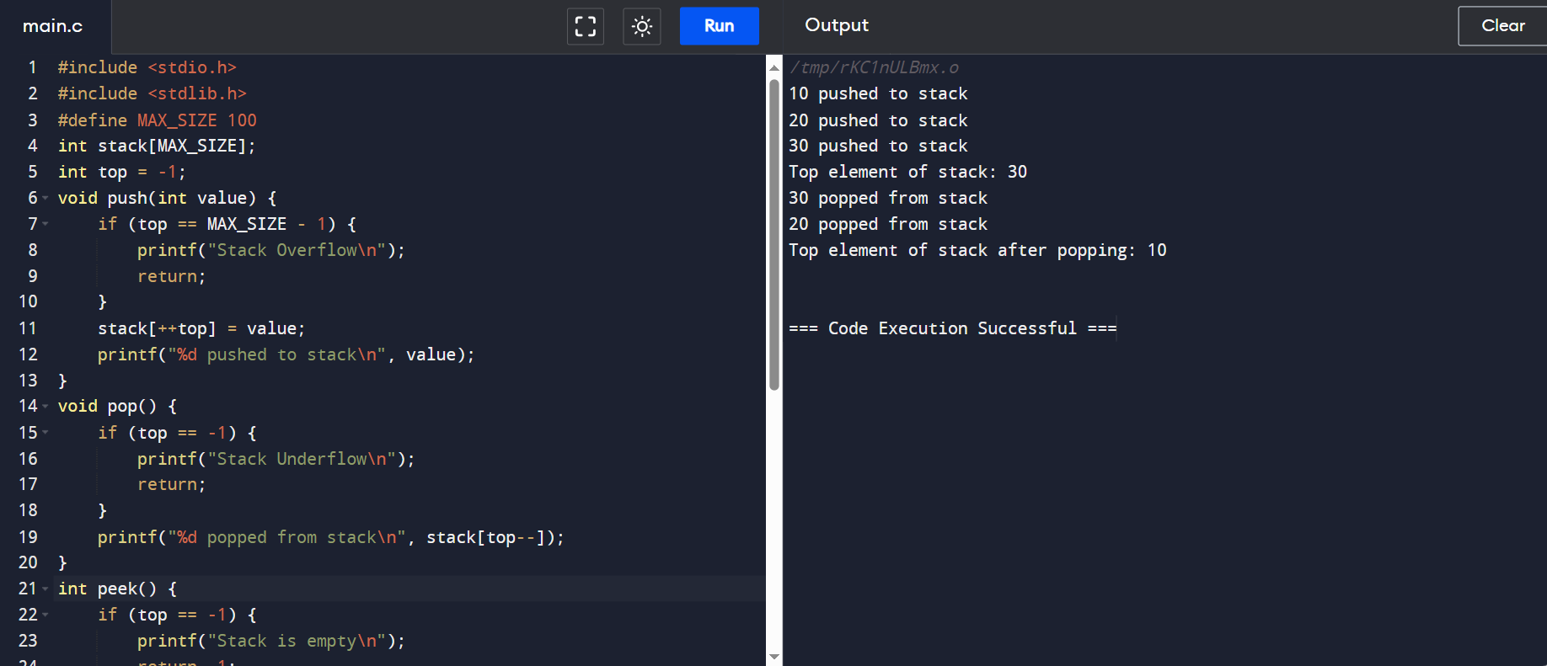

**OUTPUT:**

